INDIA’S AGRICULTURE CROP PRODUCTION ANALYSIS (1997-2021)

**INTRODUCTION:**

**1.1 OVERVIEW:**

Our project is about Indians agriculture sector. The demand for fresh and processed products of all types is increasing due to rapid urbanization rice in incomes and changing consumption habits of the population. The growth of an efficient cold chain network from “Farm to Fork” will help curb the current spoilage rate agricultural output while helping producers capture value as product retain quality and give extra benefit to customers. The country has unique competitive advantage with the largest arable land area of an estimated 179 million hectares and diverse agroclimatic conditions supporting cultivation of various crops. The agriculture sector indeed plays a virtual role in India economics, politic and society.

**1.2 PURPOSE:**

Let us analyse the India Agriculture crop production for the data collected from 1997 to 2021 production. Let us ask interesting questions on existing data, get production and area statistics and understand more on the Indian Agriculture history for crop production.

**2. Problem Definition & Design Thinking:**

**2.1 Empathy Map:**

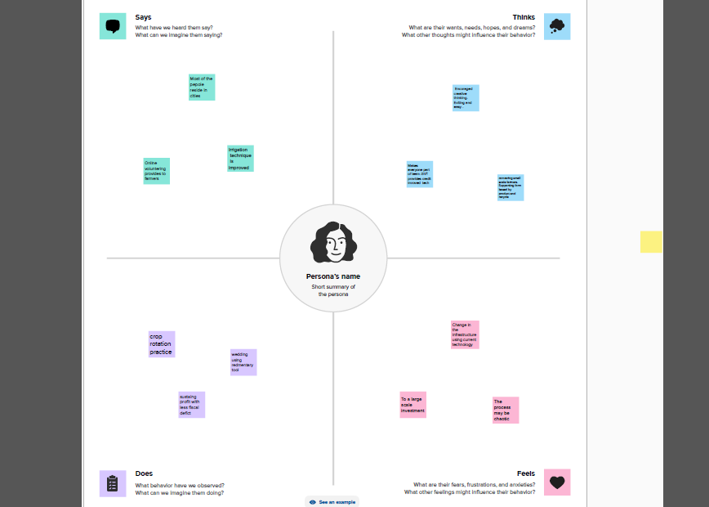

**2.2 Ideation & Brainstorming Map:**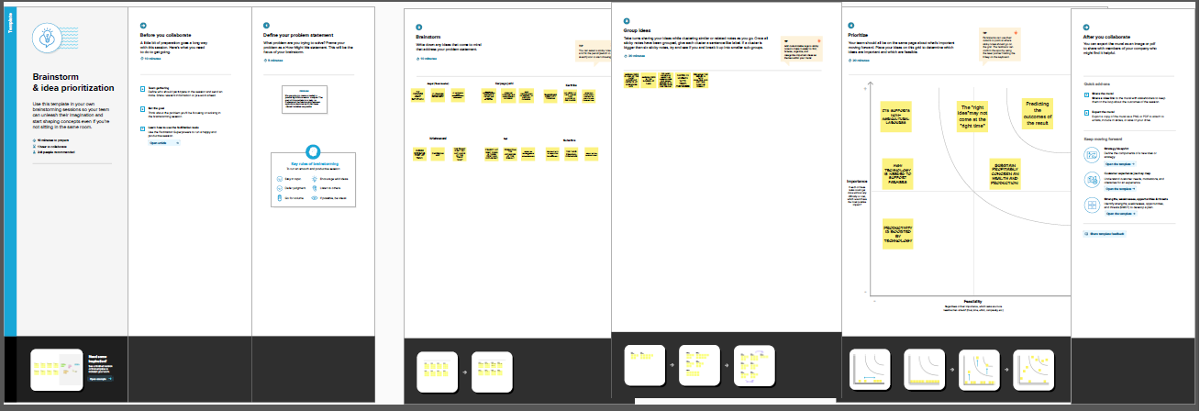

**3.RESULT:**

**Dashboard:1**

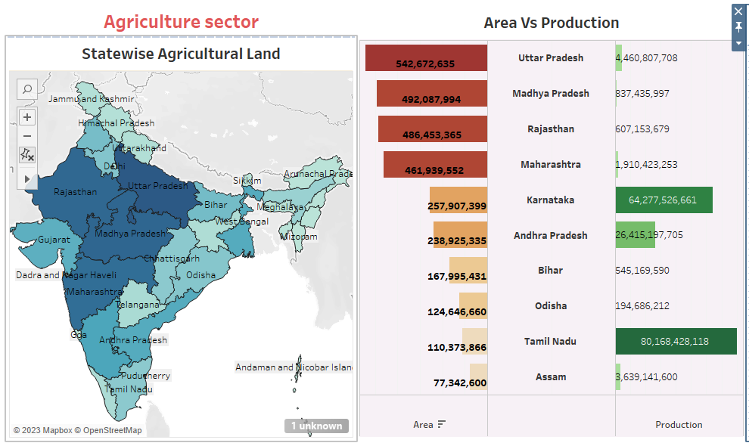

**Dashboard:2**

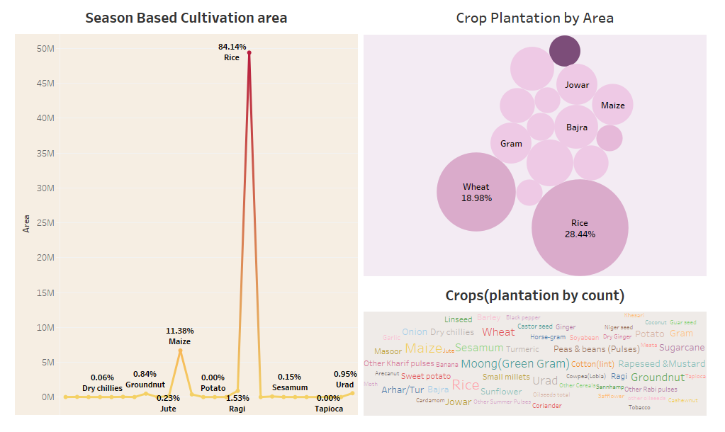

**Dashboard:3**

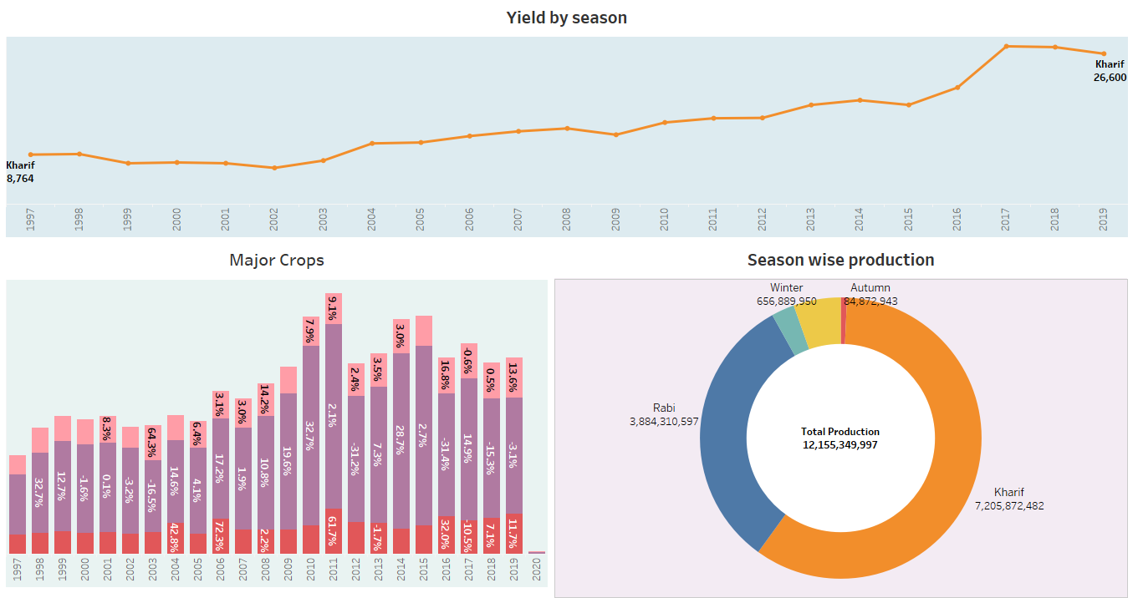

**Dashboard:4**

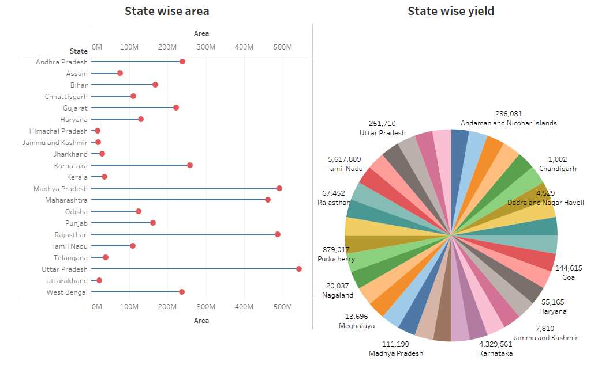

**Story:1**

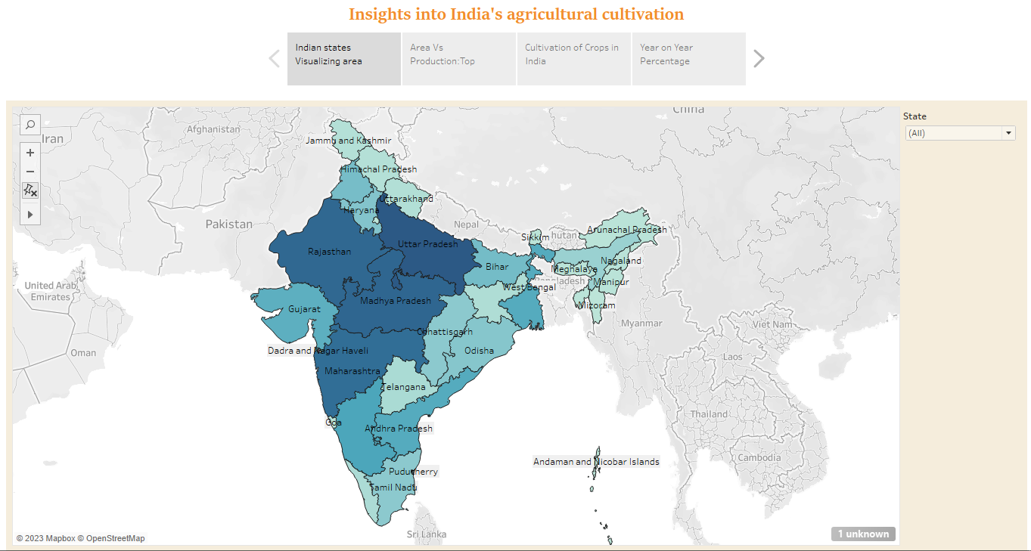

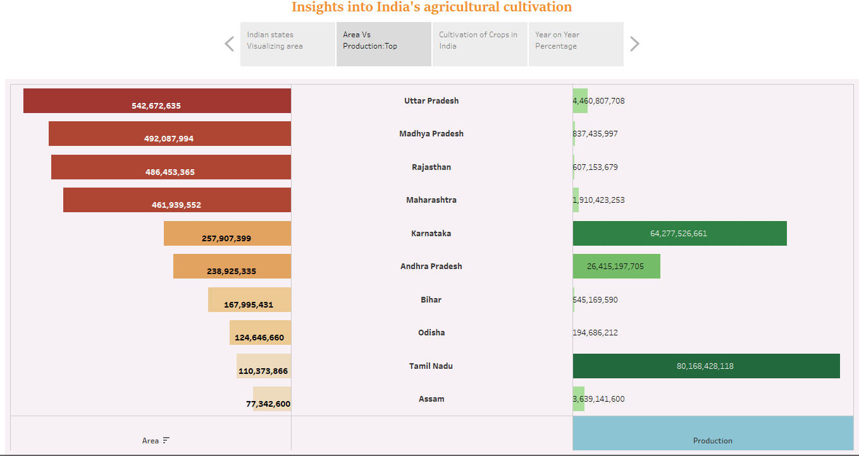

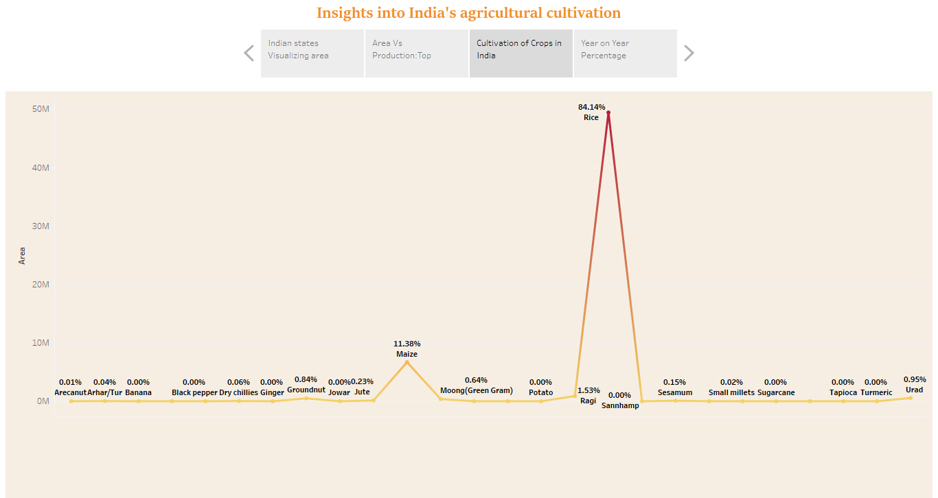

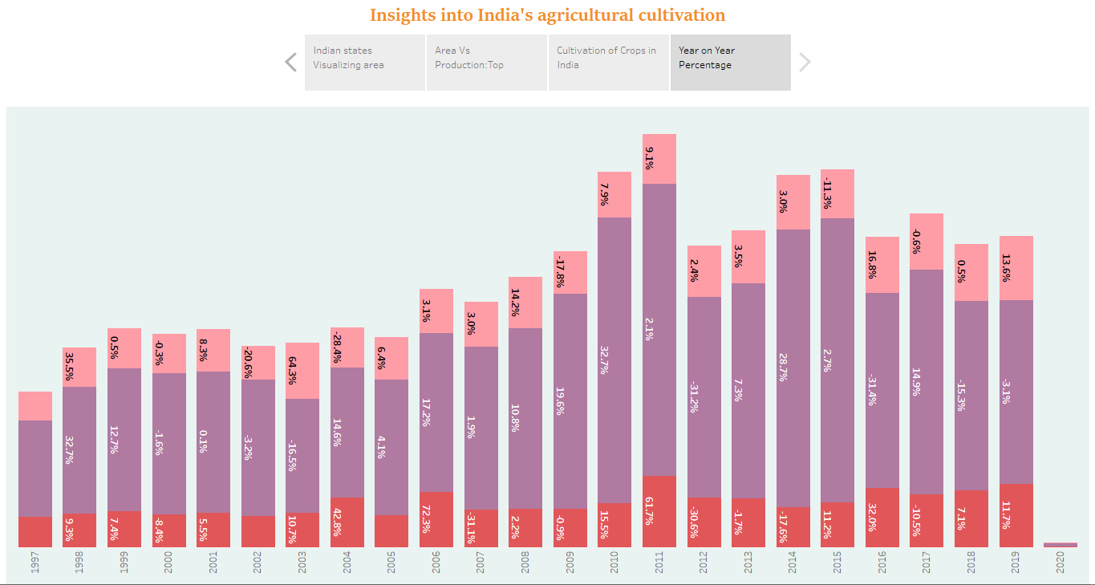

**Story:2**

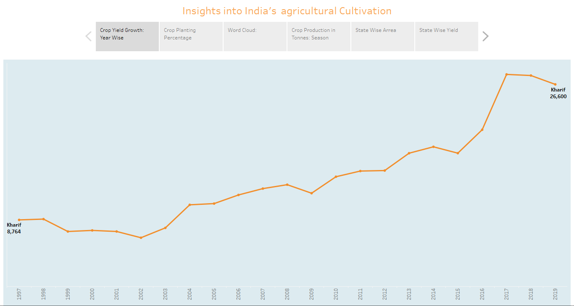

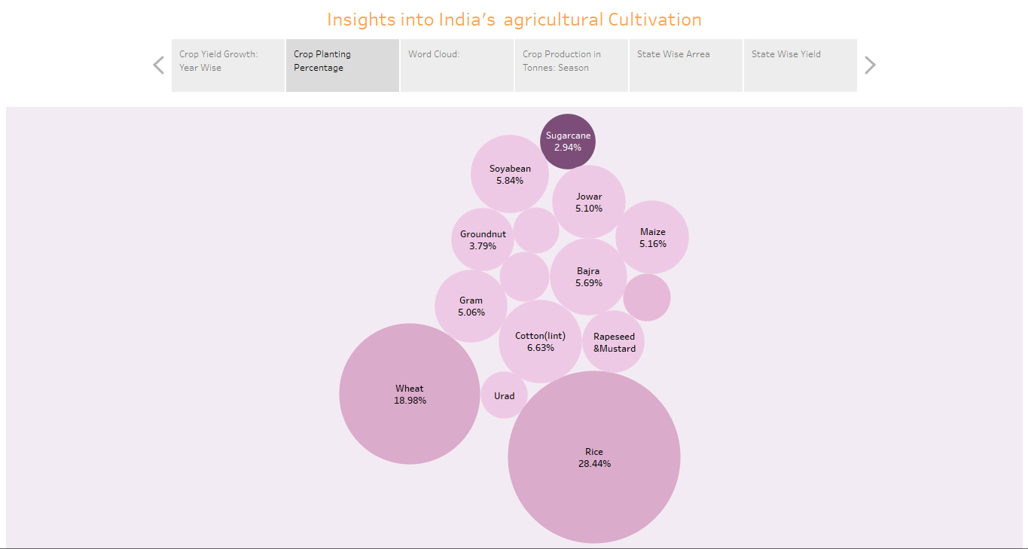

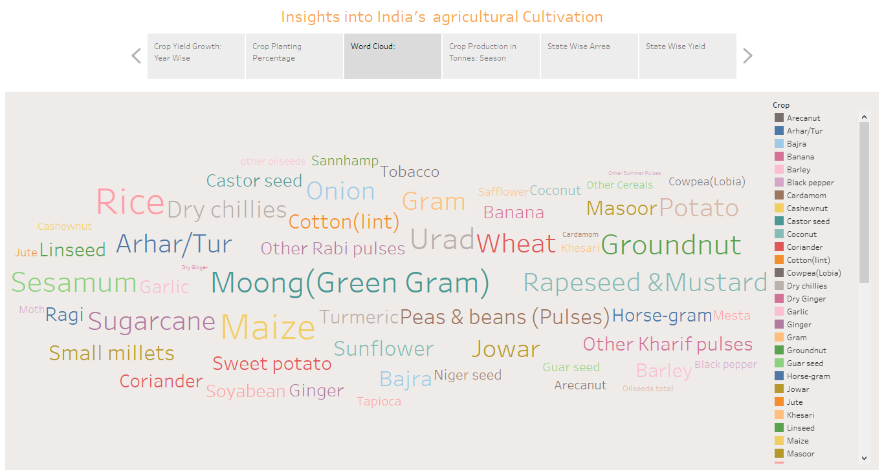

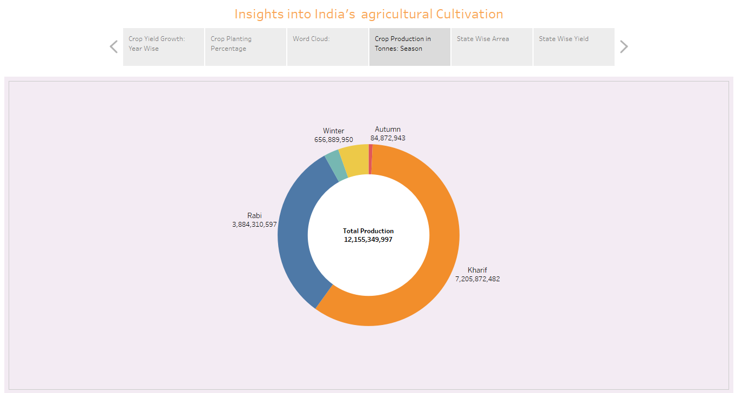

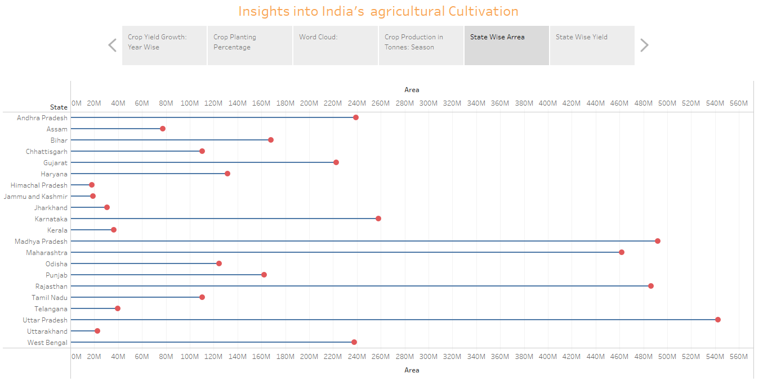

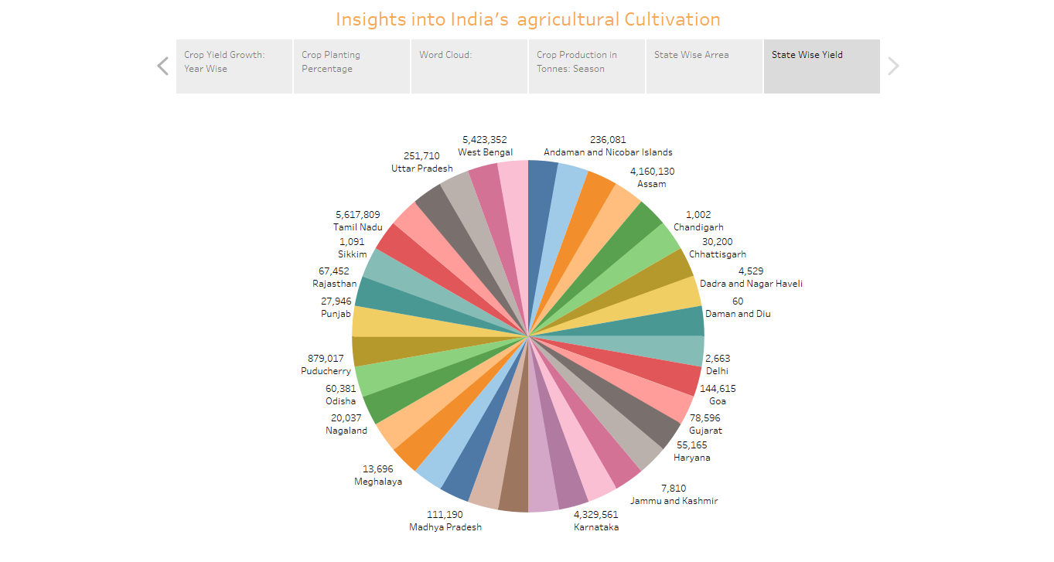

|  |  |
| --- | --- |
|  |  |

**4 . ADVANTAGES & DISADVANTAGES:**

**Advantages:**

1. Crop production in India has several advantages, such as ensuring food security, generating income for farmers, supporting rural development, and contributing to export opportunities.
2. Increase crop yield and production.
3. Improved food security and reduced dependency on imports.
4. Boost to the rural economy and employment opportunities.
5. Technological advancement and modern farming practice.
6. Diversification of crop leading to better market opportunities.

**Disadvantages:**

1. Some challenges in crop production include unpredictable weather patterns, pest and disease outbreaks, limited access to modern farming techniques, and fluctuating market prices.
2. Over-reliance on chemical fertilizers and pesticides, leading to environmental issues.
3. Unequal distribution of resources and benefits among farmers.
4. Decreased biodiversity and loss of traditional farming practices.
5. Market fluctuations and price volatility affecting farmers income.

**5.APPLICATION:**

Crop production is used for various purposes, including food production, animal feed, fibbers production, and raw materials for industries. Some of the applications include remote sensing, satellite imagery, GIS( Geographic Information System), and data analytics. These technology help in monitoring crop health, estimating yields, identifying crop diseases, and optimizing resource allocation in agriculture.

**6. CONCLUSION:**

Crop production plays a vital role in India’s agricultural sector, economy, and food security, but it also faces challenges that need to be addressed for sustainable and efficient farming practices.

**7. FUTURE SCOPE:**

The future of crop production in India involves sustainable farming practices, technological advancements, improved irrigation systems, and climate-smart agriculture to address challenges and enhance productivity.

**Reference:**

DASHBOARD:1 <https://public.tableau.com/views/Dashboard1_16972060082510/Dashboard1?:language=en-US&:display_count=n&:origin=viz_share_link>

DASHBOARD:2

<https://public.tableau.com/views/Dashboard2_16972688117190/Dashboard2?:language=en-US&:display_count=n&:origin=viz_share_link>

DASHBOARD:3

<https://public.tableau.com/views/Dashboard3_16972718879800/Dashboard3?:language=en-US&:display_count=n&:origin=viz_share_link>

DASBOARD:4

<https://public.tableau.com/views/Dashboard4_16972734322600/Dashboard4?:language=en-US&publish=yes&:display_count=n&:origin=viz_share_link>

STORY:1

<https://public.tableau.com/views/Story1_16972749950370/Story1?:language=en-US&:display_count=n&:origin=viz_share_link>

STORY:2

<https://public.tableau.com/views/story2_16972763527240/Story2?:language=en-US&publish=yes&:display_count=n&:origin=viz_share_link>

**Demonstration video:**

<https://drive.google.com/file/d/1JGwepqi_BqiF1DP353-Ri2sKPgvvoJ7t/view?usp=drivesdk>